**Bootstrap typography**

Let's start with HTML heading elements - <h1> through <h6>

<h1>Heading 1</h1>

<h2>Heading 2</h2>

<h3>Heading 3</h3>

<h4>Heading 4</h4>

<h5>Heading 5</h5>

<h6>Heading 6</h6>

The headings from h1 through h6 will be as shown below without bootstrap   
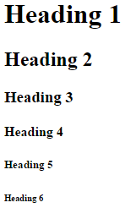  
  
With bootstrap the headings are as shown below.   
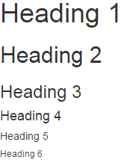  
  
**Bootstrap also has classes from h1 through h6.** These classes are useful when you want to match the font styling of a heading but still want your text to be displayed inline. Let us understand what we mean by this with an example.

<h4>Bootstrap</h4> is a free, open-source and is the most popular

HTML, CSS, and JavaScript framework developed by twitter for creating responsive

web applications. It includes HTML and CSS based design templates for common user

interface components like Buttons, Dropdowns, Typography, Tabs, Forms, Tables,

Navigations, Alerts, Modals, Accordion, Carousel etc. along with optional JavaScript

extensions. Bootstrap framework is based on open standards - HTML, CSS and

JavaScript. This means bootstrap can be used with any server side technology and a

ny platform. You can use it with any web application built with any server side

technology like ASP.NET, JAVA, PHP etc.

In the above html, we are using <h4> element with the word Bootstrap. Since <h4> is a block element it will render the word "Bootstrap" as if there is a line break before and after it as shown below.   
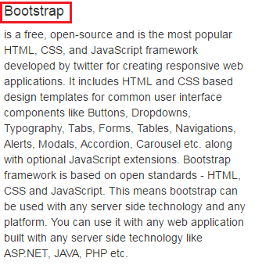  
  
If you want the word "Bootstrap" to match the font style of <h4>, but still want the word to be displayed inline with other text then use h4 bootstrap class.

<span class="h4">Bootstrap</span> is a free, open-source and is the most popular

HTML, CSS, and JavaScript framework developed by twitter for creating responsive

web applications. It includes HTML and CSS based design templates for common

user interface components like Buttons, Dropdowns, Typography, Tabs, Forms,

Tables, Navigations, Alerts, Modals, Accordion, Carousel etc. along with

optional JavaScript extensions. Bootstrap framework is based on open standards

- HTML, CSS and JavaScript. This means bootstrap can be used with any server

side technology and any platform. You can use it with any web application built

with any server side technology like ASP.NET, JAVA, PHP etc.

With h4 class, the word "Bootstrap" will be displayed inline with the other text as shown below.   
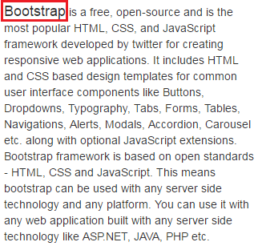  
  
Another example where we could use .h1 through .h6 classes. Let us say we want to display all the headings from h1 to h6 in a single row as shown below.   
bootstrap header classes  
  
If we use the html elements <h1> through <h6> as shown below

<h1>H1</h1> <h2>H2</h2> <h3>H3</h3> <h4>H4</h4> <h5>H5</h5> <h6>H6</h6>

The headers will not be in the same line, as all the headers are block elements.   
html h1 to h6 tags  
  
Instead use .h1 through .h6 classes as shown below

<span class="h1">H1</span><span class="h2">H2</span><span class="h3">H3</span>

<span class="h4">H4</span><span class="h5">H5</span><span class="h6">H6</span>

If you want to create a lighter secondary text along with the main text in any heading, you can use either <small> tag or the .small class.   
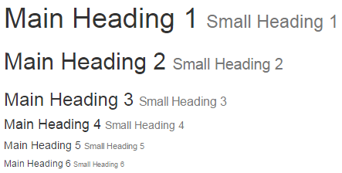  
  
**Creating secondary text in a heading using the <small> tag**

<h1>Main Heading 1 <small>Small Heading 1</small></h1>

<h2>Main Heading 2 <small>Small Heading 2</small></h2>

<h3>Main Heading 3 <small>Small Heading 3</small></h3>

<h4>Main Heading 4 <small>Small Heading 4</small></h4>

<h5>Main Heading 5 <small>Small Heading 5</small></h5>

<h6>Main Heading 6 <small>Small Heading 6</small></h6>

**Creating secondary text in a heading using the .small class**

<h1>Main Heading 1 <span class="small">Small Heading 1</span></h1>

<h2>Main Heading 2 <span class="small">Small Heading 2</span></h2>

<h3>Main Heading 3 <span class="small">Small Heading 3</span></h3>

<h4>Main Heading 4 <span class="small">Small Heading 4</span></h4>

<h5>Main Heading 5 <span class="small">Small Heading 5</span></h5>

<h6>Main Heading 6 <span class="small">Small Heading 6</span></h6>